Adjective Attribute

✅ What is Adjective Attribute?
# Source: AI Source: Provided by: [Data Path: Persons Table -> ID Column: 1, Name_En Column: Motasem Essam] -> From: [Chatgpt (GPT‑5 Mini)] on [8/7/2025]
An Adjective Attribute is an adjective that directly modifies a noun by describing its quality, state, or characteristic. It functions within the noun phrase and typically comes before the noun.

🔹 Key Features:
# Source: AI Source: Provided by: [Data Path: Persons Table -> ID Column: 1, Name_En Column: Motasem Essam] -> From: [Chatgpt (GPT‑5 Mini)] on [8/7/2025]
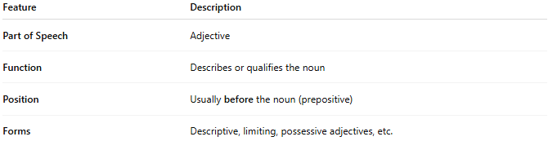
Feature | Description
Part of Speech | Adjective
Function | Describes or qualifies the noun
Position | Usually before the noun (prepositive)
Forms | Descriptive, limiting, possessive adjectives, etc.

🔹 Examples:
# Source: AI Source: Provided by: [Data Path: Persons Table -> ID Column: 1, Name_En Column: Motasem Essam] -> From: [Chatgpt (GPT‑5 Mini)] on [8/7/2025]
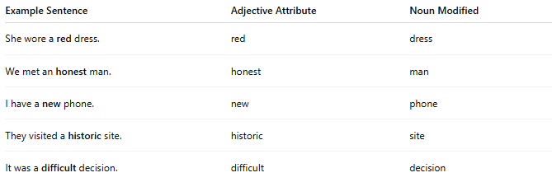
Example Sentence | Adjective Attribute | Noun Modified
She wore a red dress. | red | dress
We met an honest man. | honest | man
I have a new phone. | new | phone
They visited a historic site. | historic | site
It was a difficult decision. | difficult | decision

🔹 Prepositive vs Postpositive Adjective Attributes:
# Source: AI Source: Provided by: [Data Path: Persons Table -> ID Column: 1, Name_En Column: Motasem Essam] -> From: [Chatgpt (GPT‑5 Mini)] on [8/7/2025]
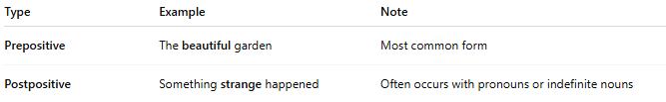
Type | Example | Note
Prepositive | The beautiful garden | Most common form
Postpositive | Something strange happened | Often occurs with pronouns or indefinite nouns

